# 240px-UMT-Logo.jpgData Science : Research Task # 1

**Problem Title:** BMI - Prediction of Health Status

**Group members Names with id:** F2018065041 Abdul Hannan

F2018065043 Syed Shahroz Abbas Shah

Your Problem Abstract: We will tell user either he/she is Extremely Weak, Weak, Normal, Overweight, Obesity, Extreme Obesity by calculating BMI (Body Mass Index) for this we need user’s age, gender, height and weight and our data set contains many samples related to this problem i.e., User’s gender, age, height and weight.

## Task: Literature Review of your Problem

**Every member in the group should generate 8 papers minimum from year 2017- 2021, If group members are consist upon 3 then whole will generate 24 papers in one word file as below template**

**IST DRAFT Template:**

|  |  |
| --- | --- |
| Paper title | Publish Year |
| Indication of Health Status - BMI | 2021 |

Journal name (Scopus, Science Direct, ACM , IEEE Explore etc ISI Impact factor) /Conference Name

**Search Query**: BMI, Prediction of Health, Health Status by BMI, Obesity Level

**Abstract**: We will tell user his/her health status by comparing the values entered by user with our data set. Our data set consists of adults less than or equal to seventy years and will give about 98% accurate results. Our model use BMI to calculate the health status i.e., Weak, Normal, Overweight and etc. The BMI is calculated using age, gender, height and weight of the user.

**Related work or algorithm/ approach**: Model Selection

**Weakness** (if any mentioned): Our model works for adults less than or equal to 70 years

**Strength**: Our model gives accurate result to adults who wants to know their health status.

**Conclusion:**  After knowing the health status the person could work upon and take care accordingly.

**Experiment Results:** Our model can give about 98% of accurate results.

**Future direction/ gap**: We will make our model accordingly for kids and teenagers in future.

**Cite /reference:** Bertakis, K. D., & Azari, R. (2005). Obesity and the use of health ca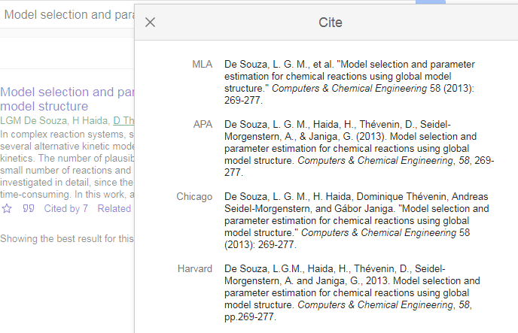re services. *Obesity research*, *13*(2), 372-379. 

https://scholar.google.com.pk/ ( APA format) or use EndNote or Mendely

Note: All sections must be written in your own wordings.

# Sample Example:

## *COBOTS - A Cognitive Multi-Bot Conversational Framework for Technical Support*

**Search Query**: COBOTS, Technical Support, Cognitive, Conversational Framework

**Abstract**: Queries related to technical support are quite difficult to resolve by a simple bot. This paper shows the conversational framework which is scalable that builds an automated bot called COBOTS. By following co-ordination and control, we can apply frameworks with scalability.

**Related work or algorithm/ approach**: These COBOTS can understand problems from the users, conversation building, and help and assist the troubleshooting.

**Strength**: Technical support of different domains can control user problems up to 11.

**Conclusion:** The system through improved framework was able to control and manage the different domains.

**Experiment Results**: 75% of the time, the Bot was able to give relevant answers.

Cite /reference : “Subramaniam, S., Aggarwal, P., Dasgupta, G.B. and Paradkar, A., 2018, July. COBOTS-A Cognitive Multi-Bot Conversational Framework for Technical Support. In *Proceedings of the 17th International Conference on Autonomous Agents and MultiAgent Systems* (pp. 597-604). International Foundation for Autonomous Agents and Multiagent Systems.”